MUHAMMAD MUDASSAR ANWAR

CMS ID-456925

ME-15 SEC A

CS-114

FUNDAMENTAL OF COMPUTER PROGRAMMING

10 OCT 2023

TASK 1:

#include<iostream>

using namespace std;

int main()

{int x;

cout<<"enter your marks";

cin>>x;//input by user

if(x<=100&&x>=90){cout<<"you obtained grade=A"<<endl;

}

if(x<90&&x>=75){cout<<"you obtained grade=B"<<endl;

}

if(x<75&&x>=60){cout<<"your grade is C"<<endl;

}

if(x<60&&x>=45){cout<<"youre grade is D"<<endl;

}

if(x<45&&x>=0){cout<<"your grade is F"<<endl;

}//criteria for grading

return0;

}//result declared

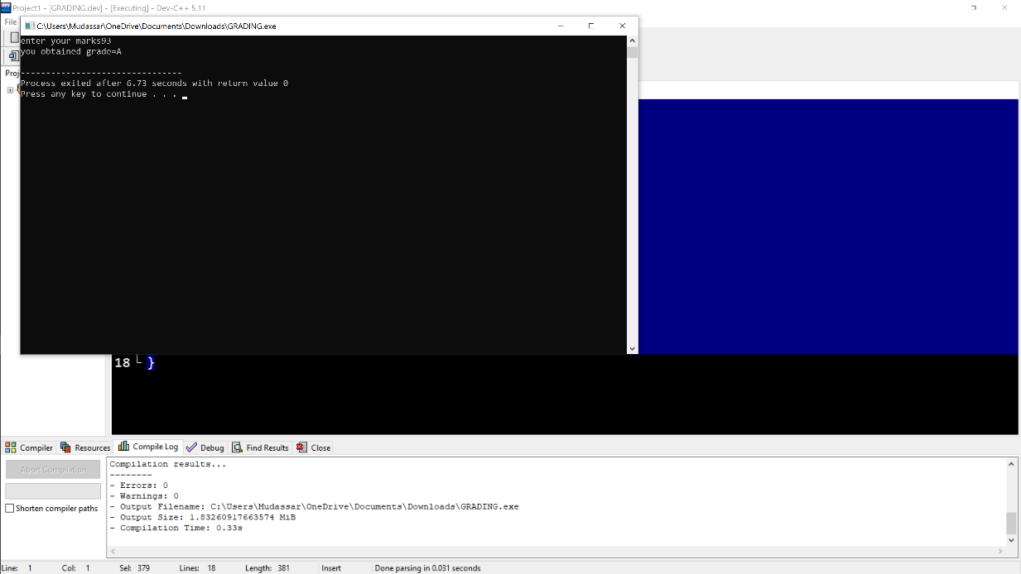

TASK2:

using namespace std;

int main()

{

int x;

cout<<"enter the number"<<endl;

cin>>x;//input by user

if(x%2==0&&x%5==0){cout<<"given number is an even number and divisible by 5"<<endl;

}//condition for even number and divisible by 5

else

{cout<<"number is not an even number or not divisible by 5"<<endl;

}//condition if x is not an even number or not divisible by 5

return 0;}

TASK 3:

#include<iostream>

using namespace std;

int main()

{

int x;

cout<<"ENTER YEAR="<<endl;//statement on computer screen

cin>>x;//input by user

if(x%4==0){cout<<"This is a leap year"<<endl;

}//condition 1

else

{cout<<"This is not a leap year"<<endl;

}//condition 2

return 0;}

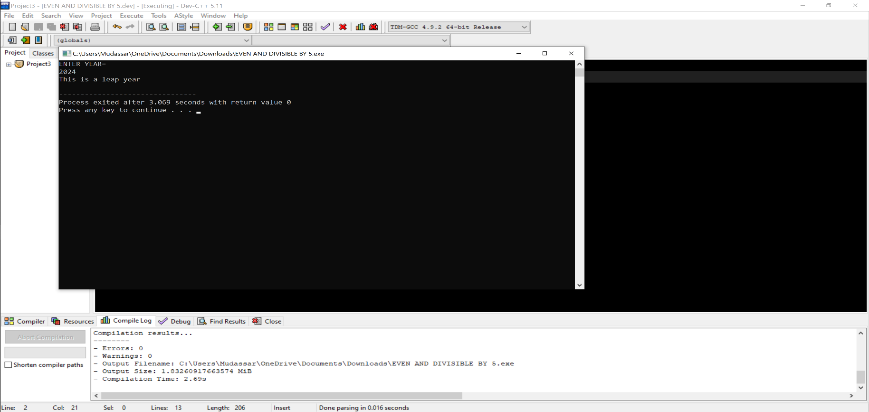

TASK 4:

#include<iostream>

using namespace std;

int main()

{

double x,y;

cout<<"enter your CGPA"<<endl;//input your cgpa

cin>>x;

cout<<"enter your attendance percentage"<<endl;//input of attendance percentage

cin>>y;

if(x>=3.5&&y>=80){cout<<"you are applicable for scholarship"<<endl;//condition 1

}

else

{cout<<"you are not applicable for scholarship"<<endl;//condition 2

}

return 0;

}

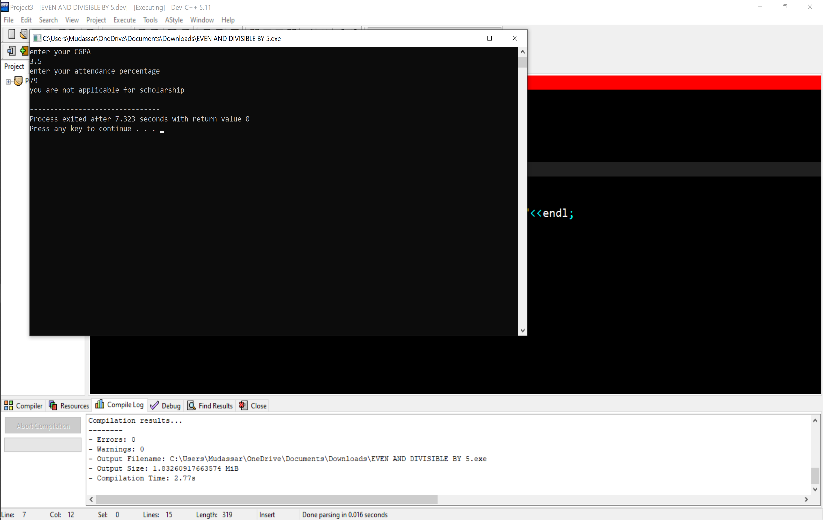

TASK 5:

#include<iostream>

using namespace std;

int main()

{char alphabet;//introduction of char function dut to character

cout<<"enter alphabet"<<endl;//console on print screen

cin>>alphabet;//input by user

if(alphabet=='a'||alphabet=='e'||alphabet=='i'||alphabet=='o'||alphabet=='u')//introducton of condition

{cout<<"alphabet is vowel"<<endl;

}//result if alphabet is vowel

else

{cout<<"alphabet is consonent"<<endl;//result if alphabet is consonenet

}

return 0;

}

